APS106: Getting Started with Python and Wing101 Version 8 for Windows

# Step 1: Install Python

1. Open your web browser and go to http://www.python.org/
2. Click “Downloads”

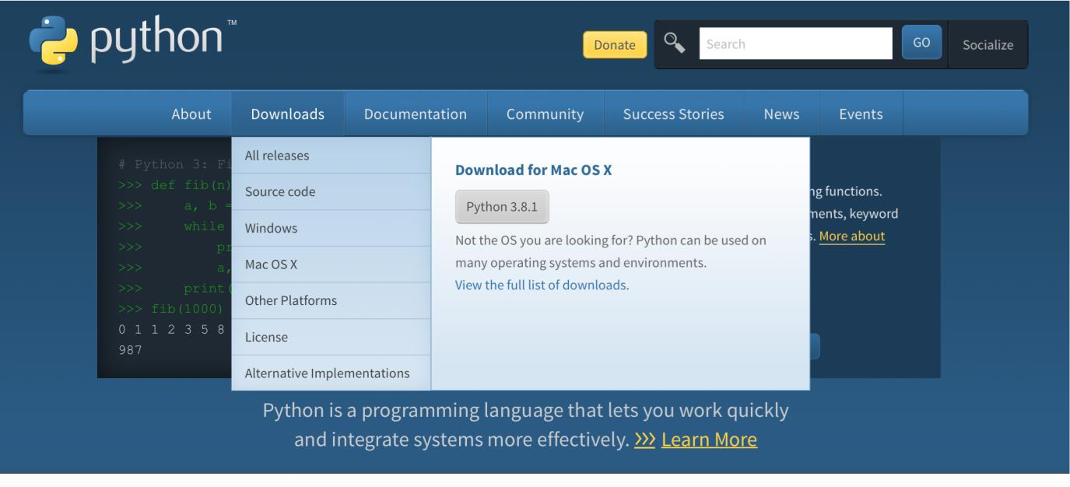

1. From the Downloads page, scroll down to “Looking for a specific release?”
2. Scroll through the release versions and click “Download” for Python version 3.8.10
   1. This is the last full release of 3.8, which is the same Python version run by the auto-marker (MarkUs) used to mark parts of your APS106 labs

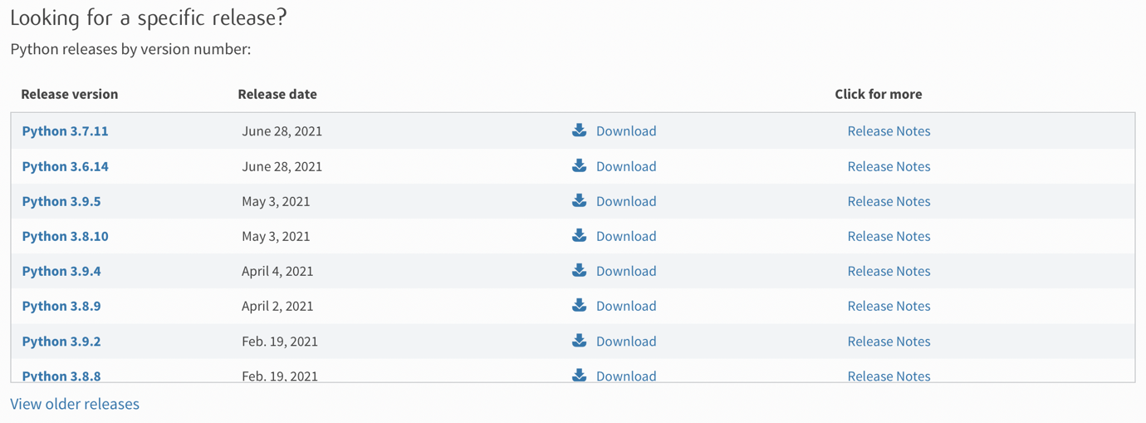

1. Once on the Python 3.8.10 download page:
   1. Scroll down and click “Windows installer (64-bit)” and save/download the file
   2. Windows users will need to pick the appropriate 32-bit or 64-bit installer based on their machine

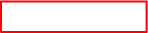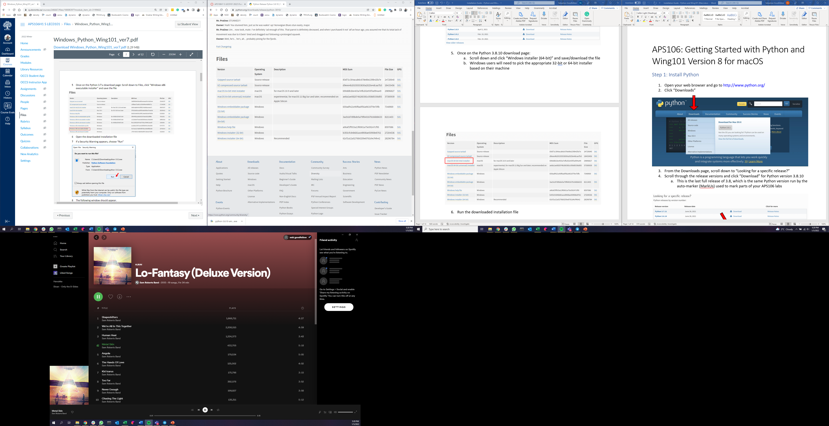

1. Run the downloaded installation file
2. The following window should appear:

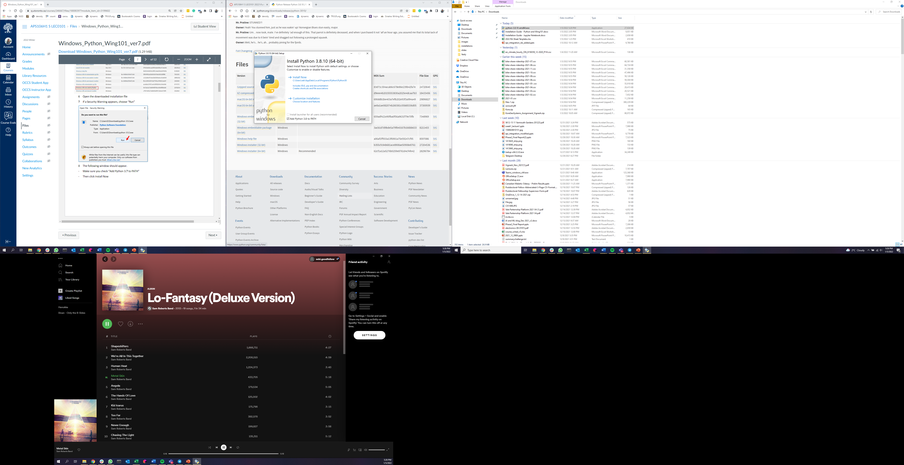

1. Make sure you check “Add Python 3.8 to PATH”
2. Then click Install Now
3. When installation is complete, you should see this.

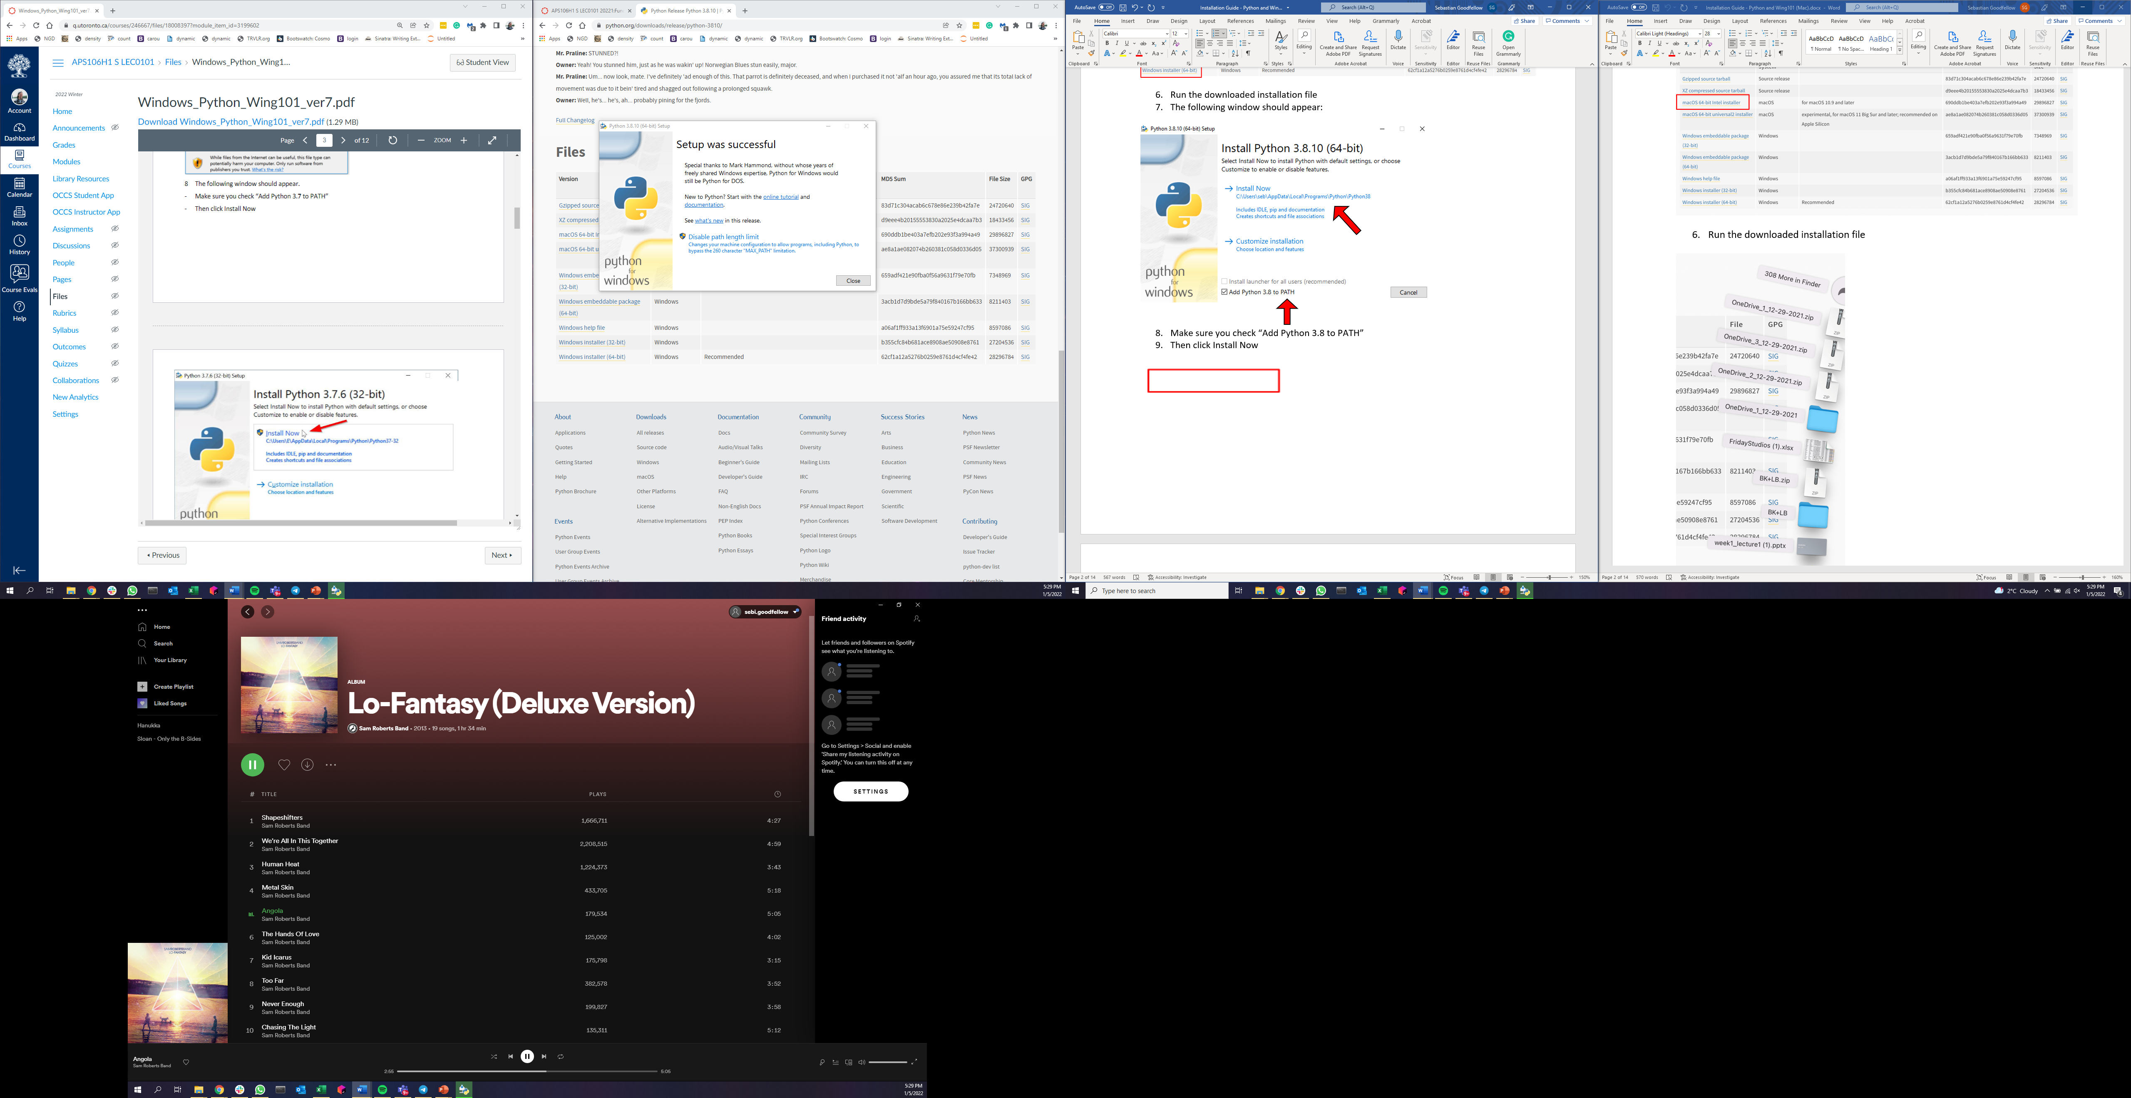

1. Click close. Python is installed!

# Step 2: Install Wing101

1. Open your web browser and go to https://wingware.com/downloads/wing-101
2. Click the green button “Windows Installer”

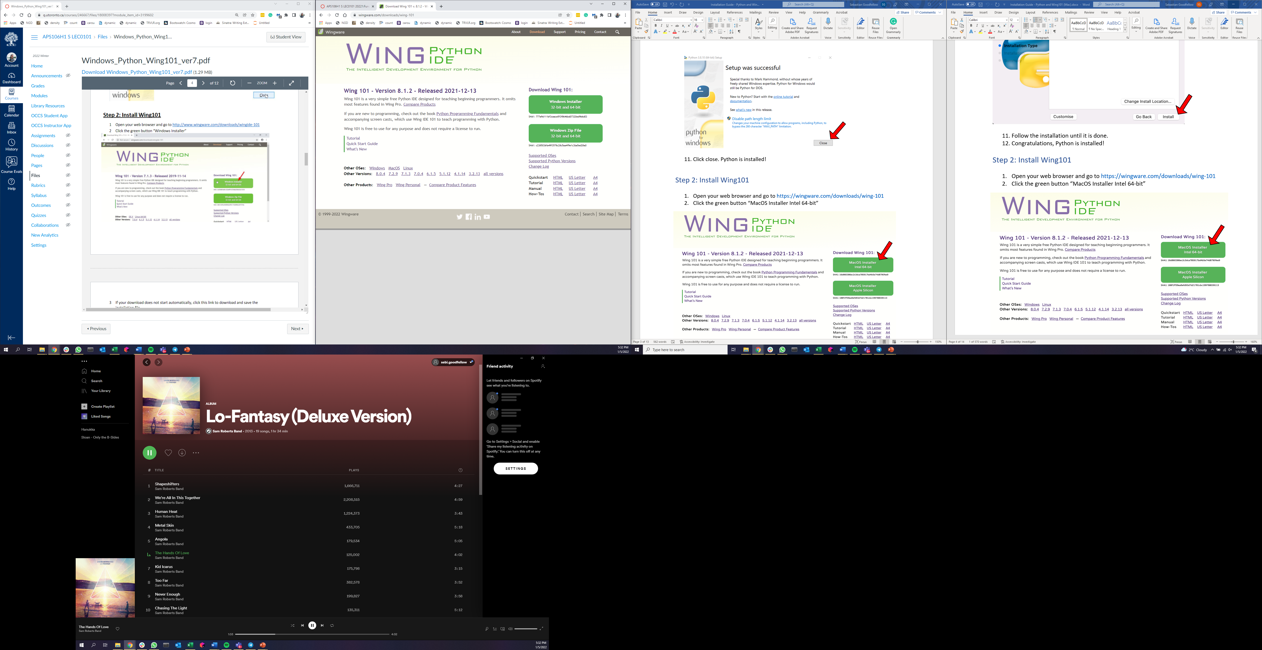

1. If your download does not start automatically, click this link to download and save the installation file:

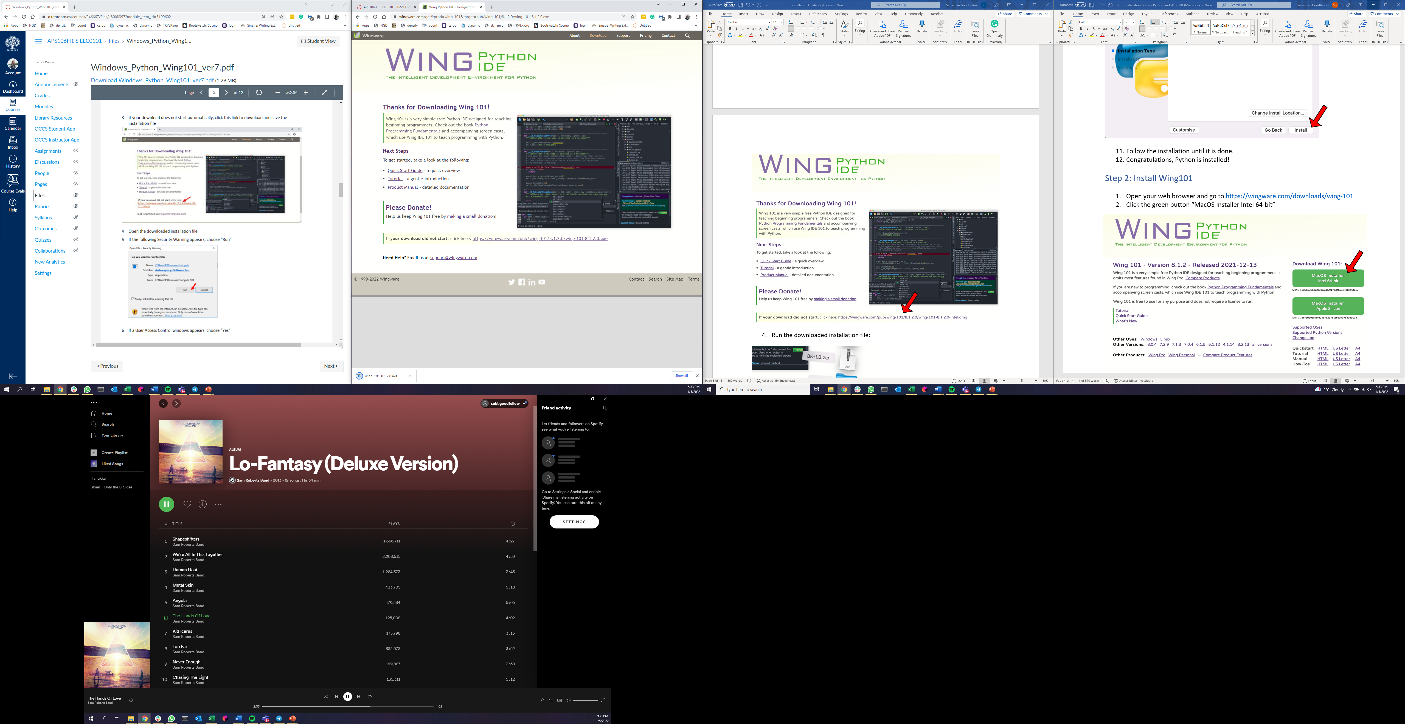

1. Run the downloaded installation file.
2. If a Security Warning appears, choose “Run”.
3. If a User Control window appears, choose “Yes”.
4. In the License Agreement make sure you choose “I accept the agreement” and then click “Next”.

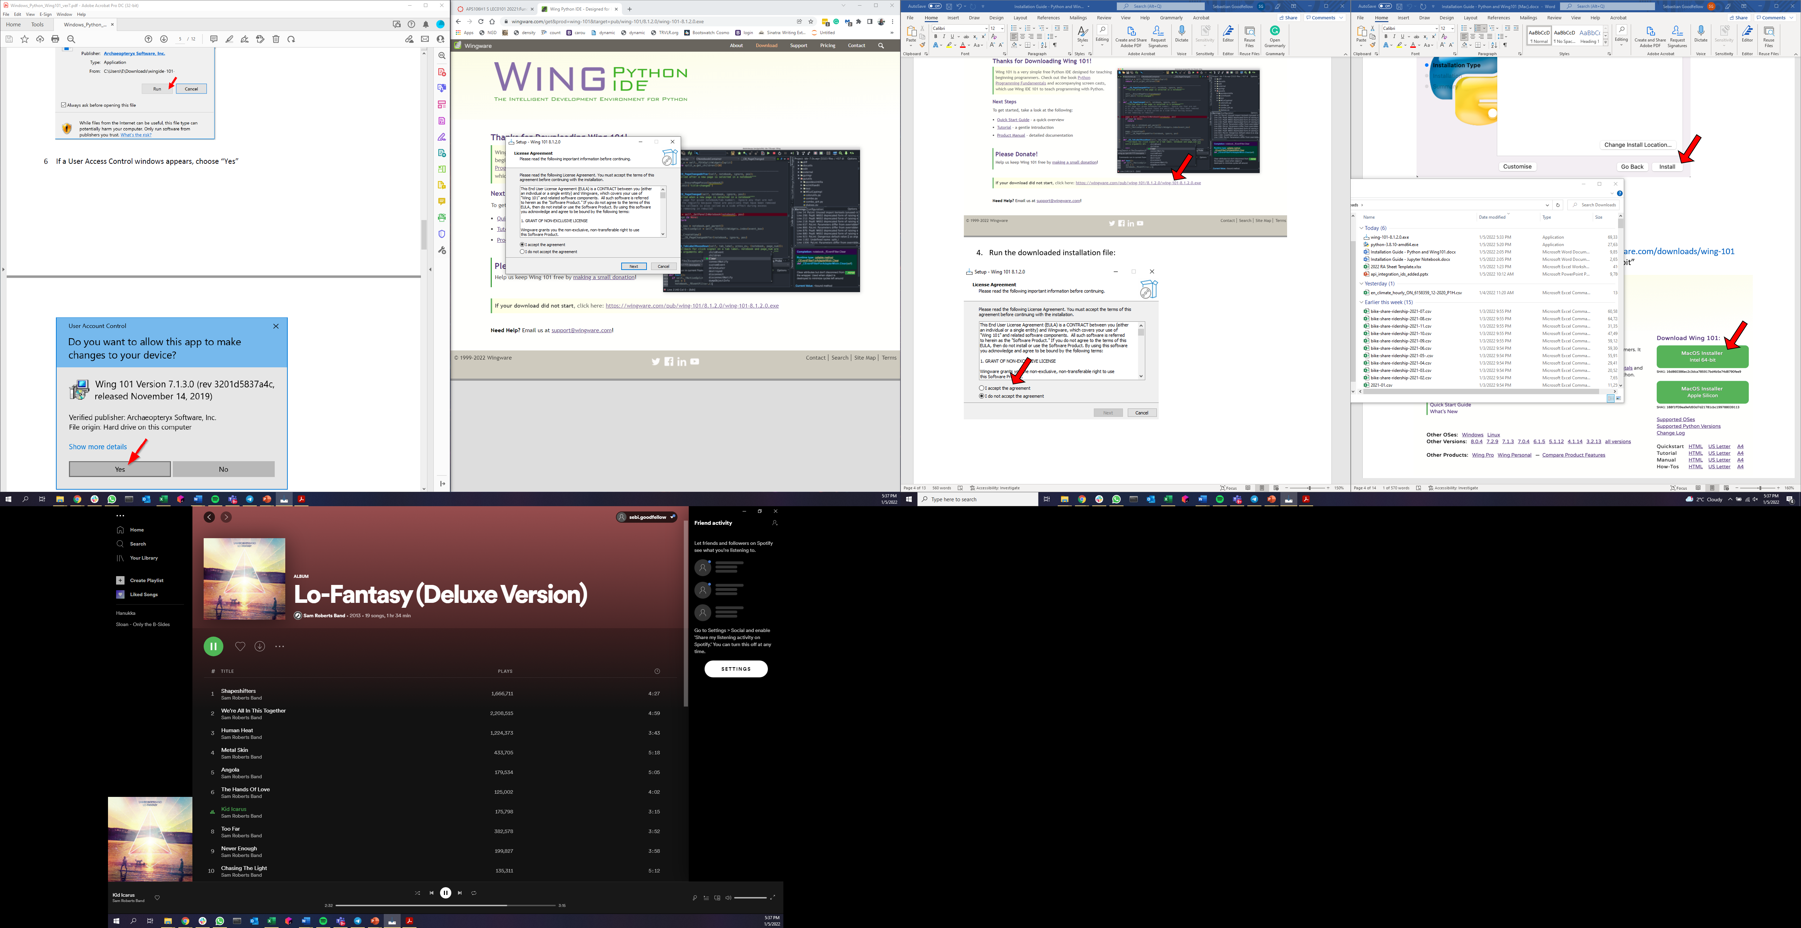

1. In the next screens choose “Next” when applicable.

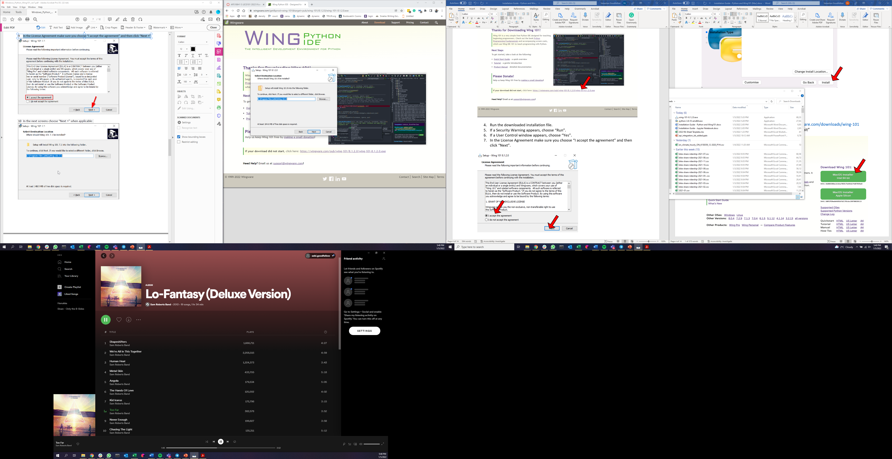

1. In the following window choose “Install”.

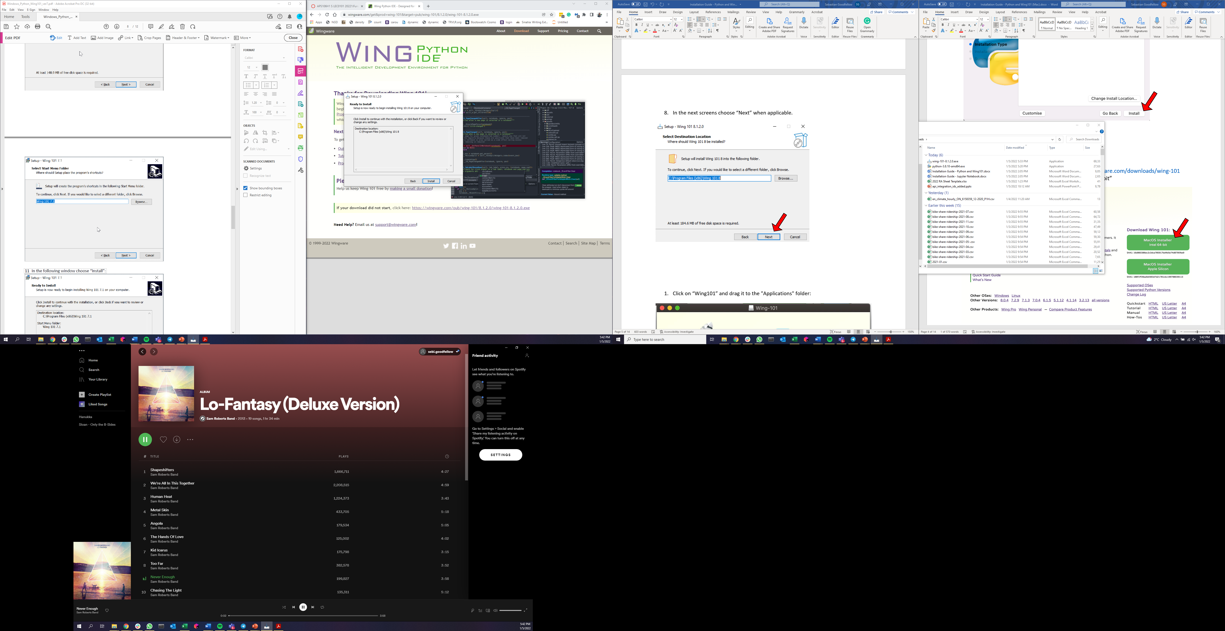

1. Wait until the installation is complete and the following screen appears. Choose “Finish”.

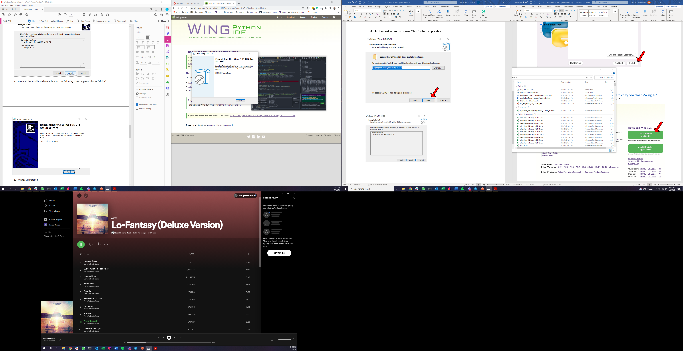

1. Wing101 is installed!

# Step 3: Running Wing101

1. From the Start menu – open Wing101:

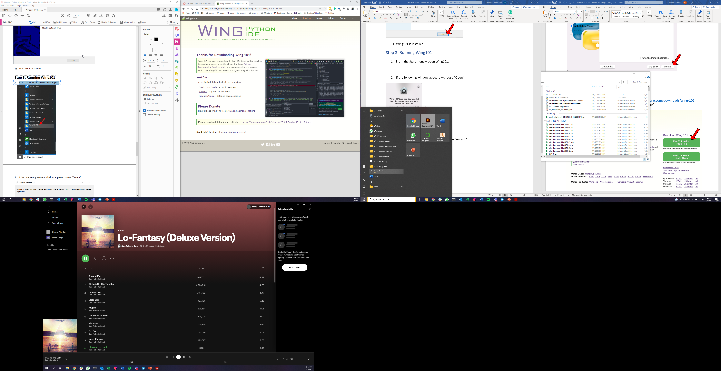

1. If the License Agreement window appears choose “Accept”.

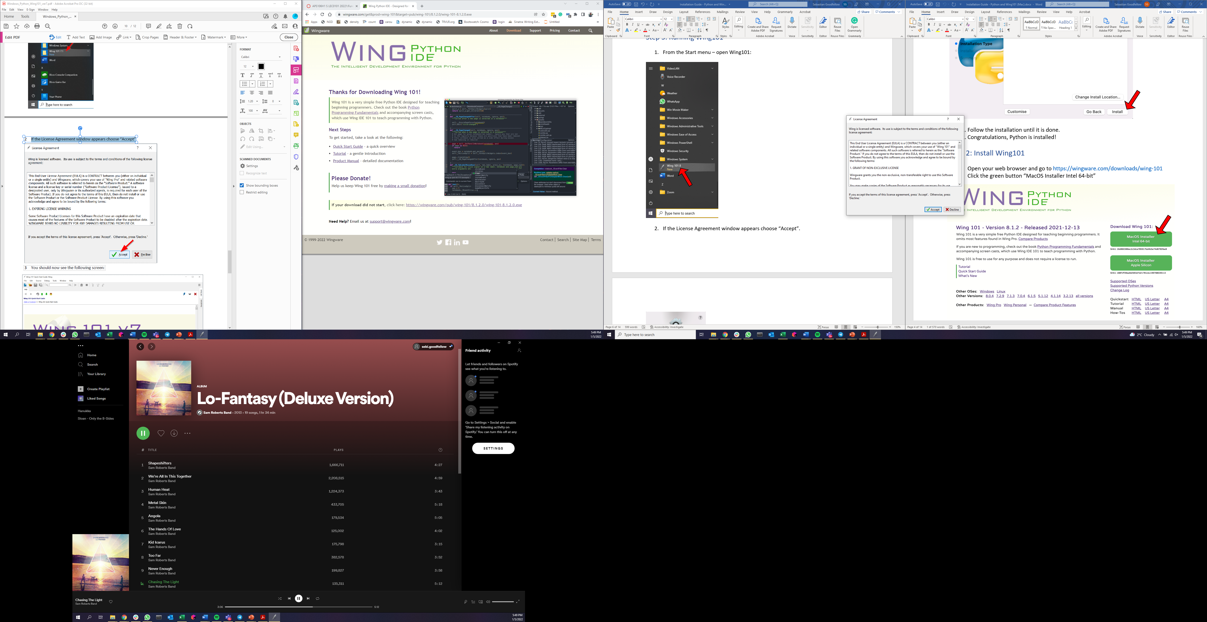

1. If you get a security alert, click “Allow Access”.

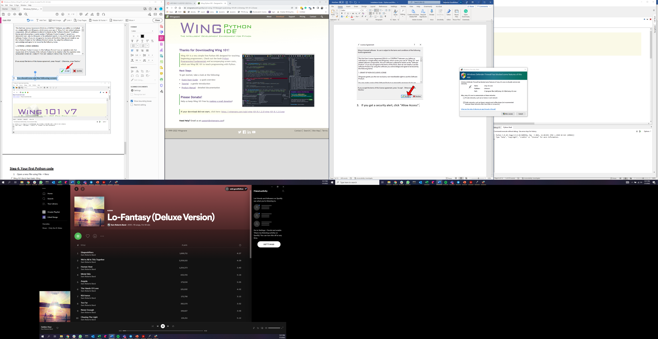

1. You should now see the following screen.

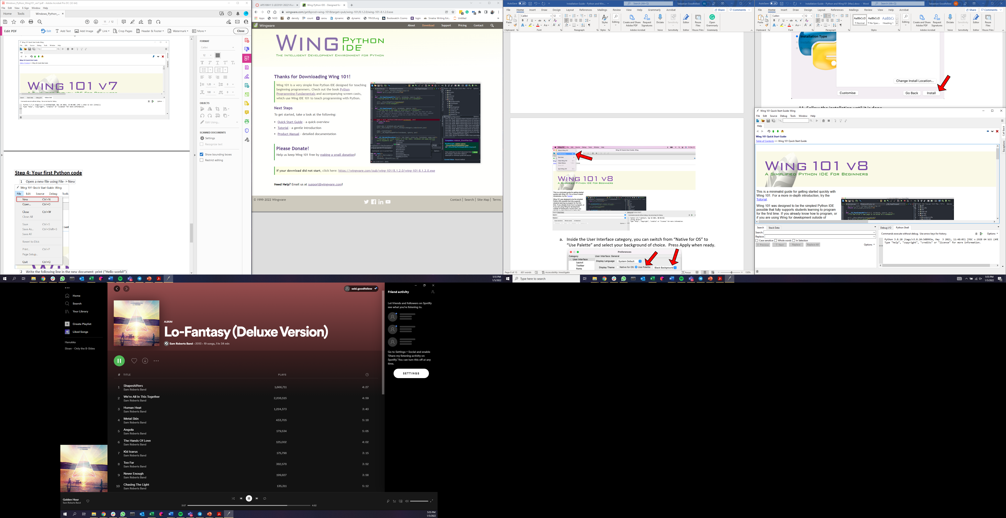

1. OPTIONAL: If you want to change your user interface color palette, go to Wing101 → Edit 🡪 Preferences

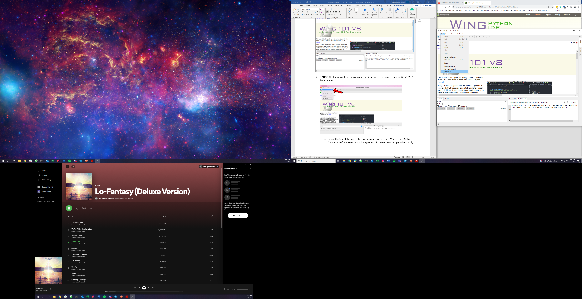

* 1. Inside the User Interface category, you can switch from “Native for OS” to “Use Palette” and select your background of choice. Press Apply when ready.

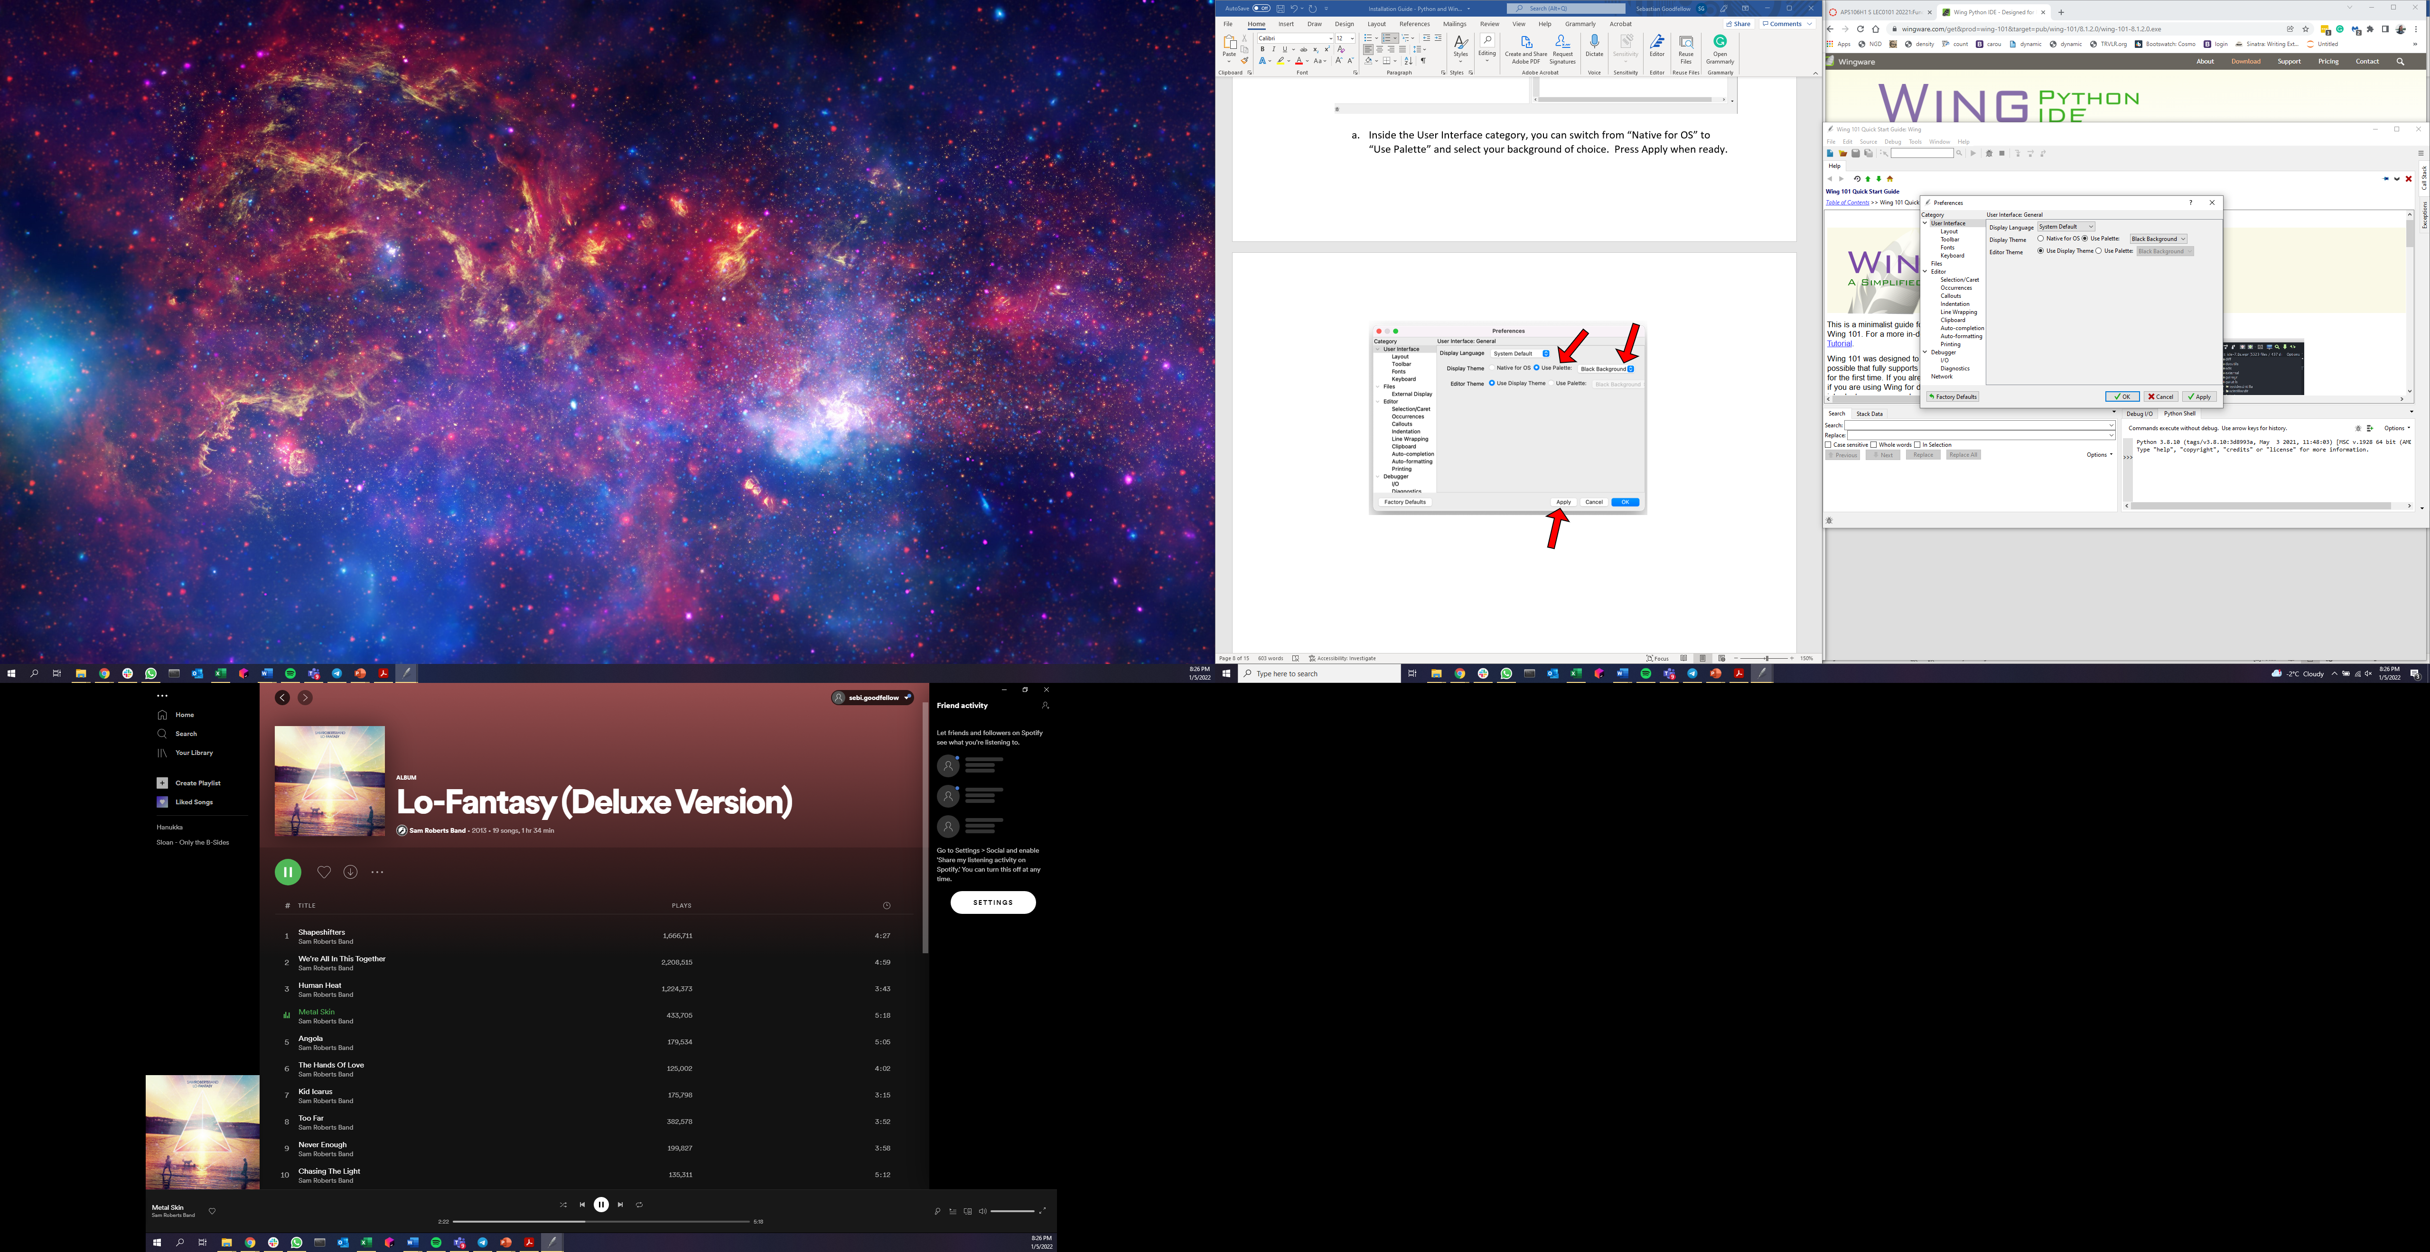

1. If the Python version listed in the Python shell is Python 3.8.10, then Wing101 is ready to use!

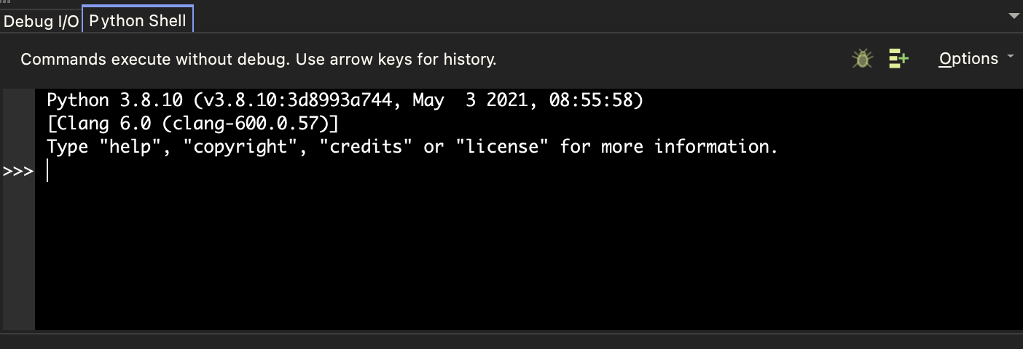

1. If the Python version listed in the Python shell is not Python 3.8, you will need to configure your Wing101 to use the correct version.

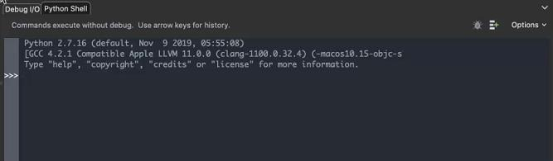

1. To change the Python version, click “Edit” → “Configure Python”

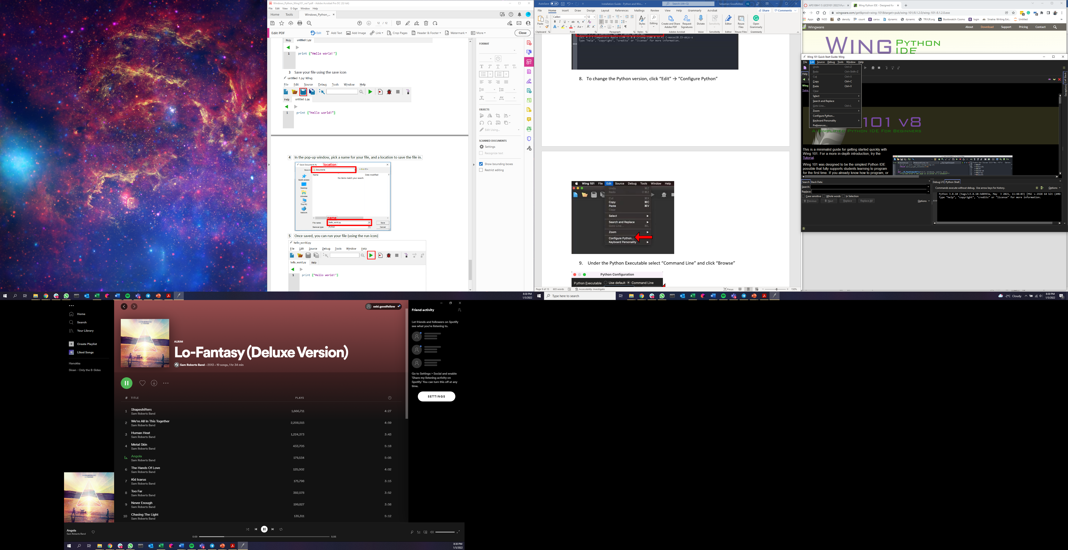

1. Under the Python Executable select “Command Line” and click “Browse”

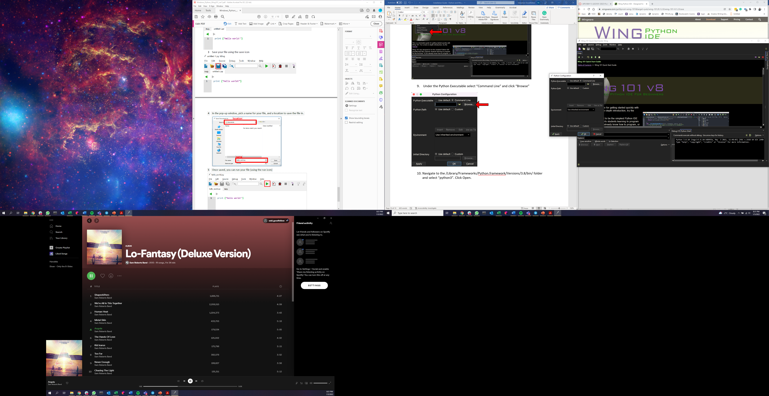

1. Navigate to the c:\Users\”Your Account Name”\AppData\Local\Programs\Python\Python38\python.exe folder and select “python.exe”. Click Open.

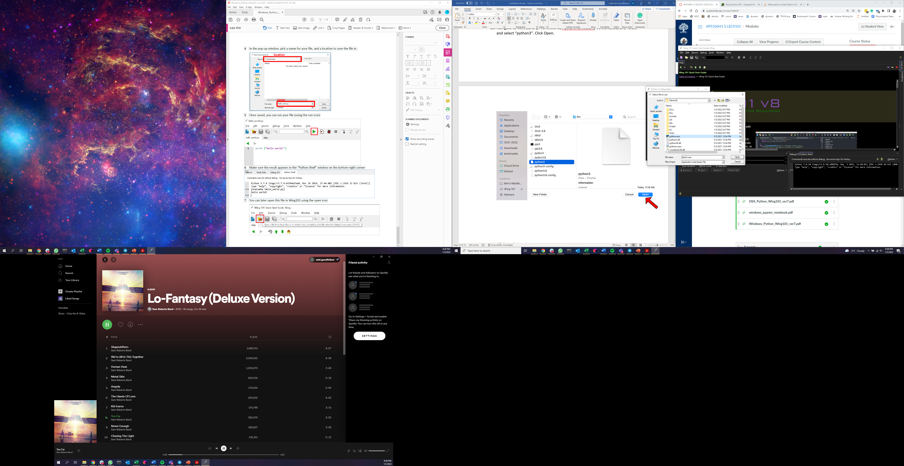

1. Click Apply
2. If you see the following prompt, click Restart.

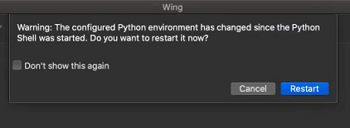

1. See that the Python version in the Python shells shows 3.8.10 now. Wing101 is now ready to use!



# Step 4: Your first Python code

1. Open a new file using File -> New

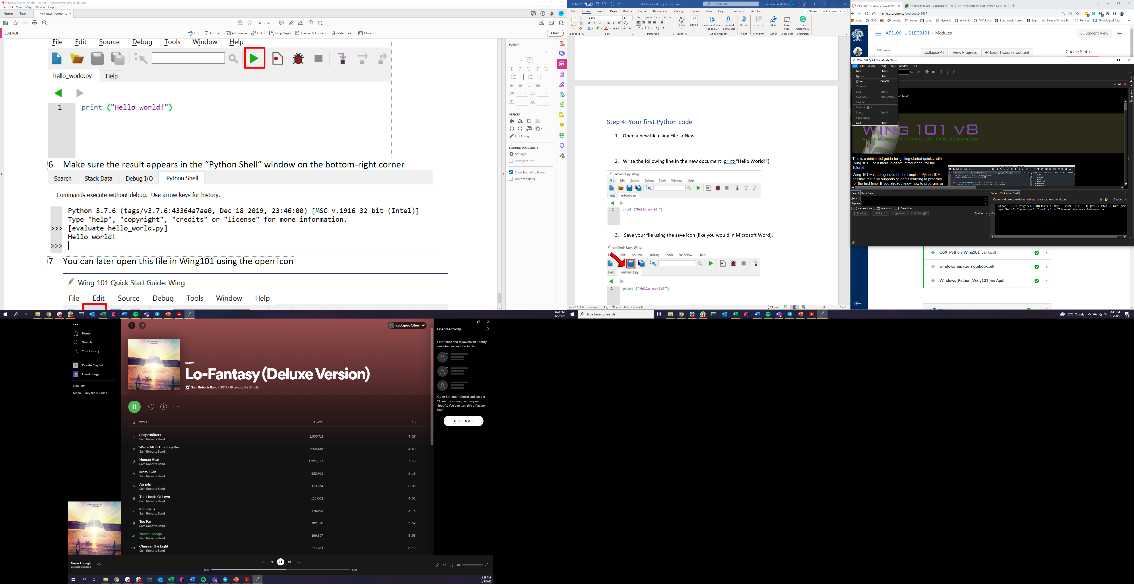

1. Write the following line in the new document: print(“Hello World!”)

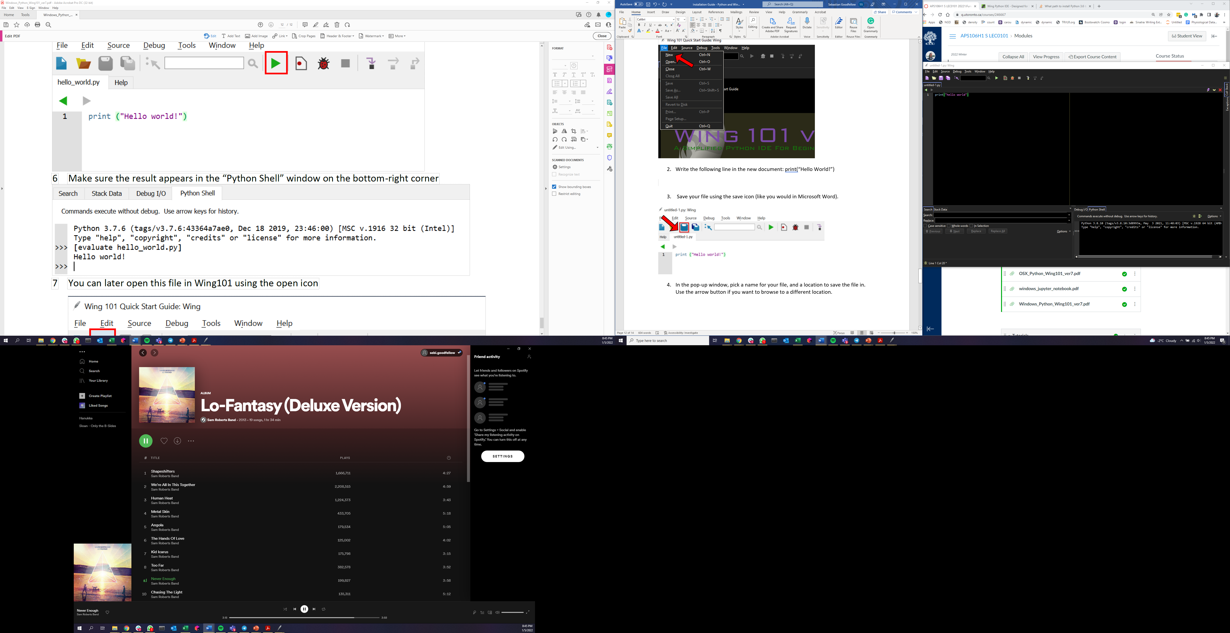

1. Save your file using the save icon (like you would in Microsoft Word).



1. In the pop-up window, pick a name for your file, and a location to save the file in. Use the arrow button if you want to browse to a different location.
2. Once saved, you can run your file (using the run icon that looks like the play symbol)



1. Make sure the result appears in the “Python Shell” window on the bottom-right corner:

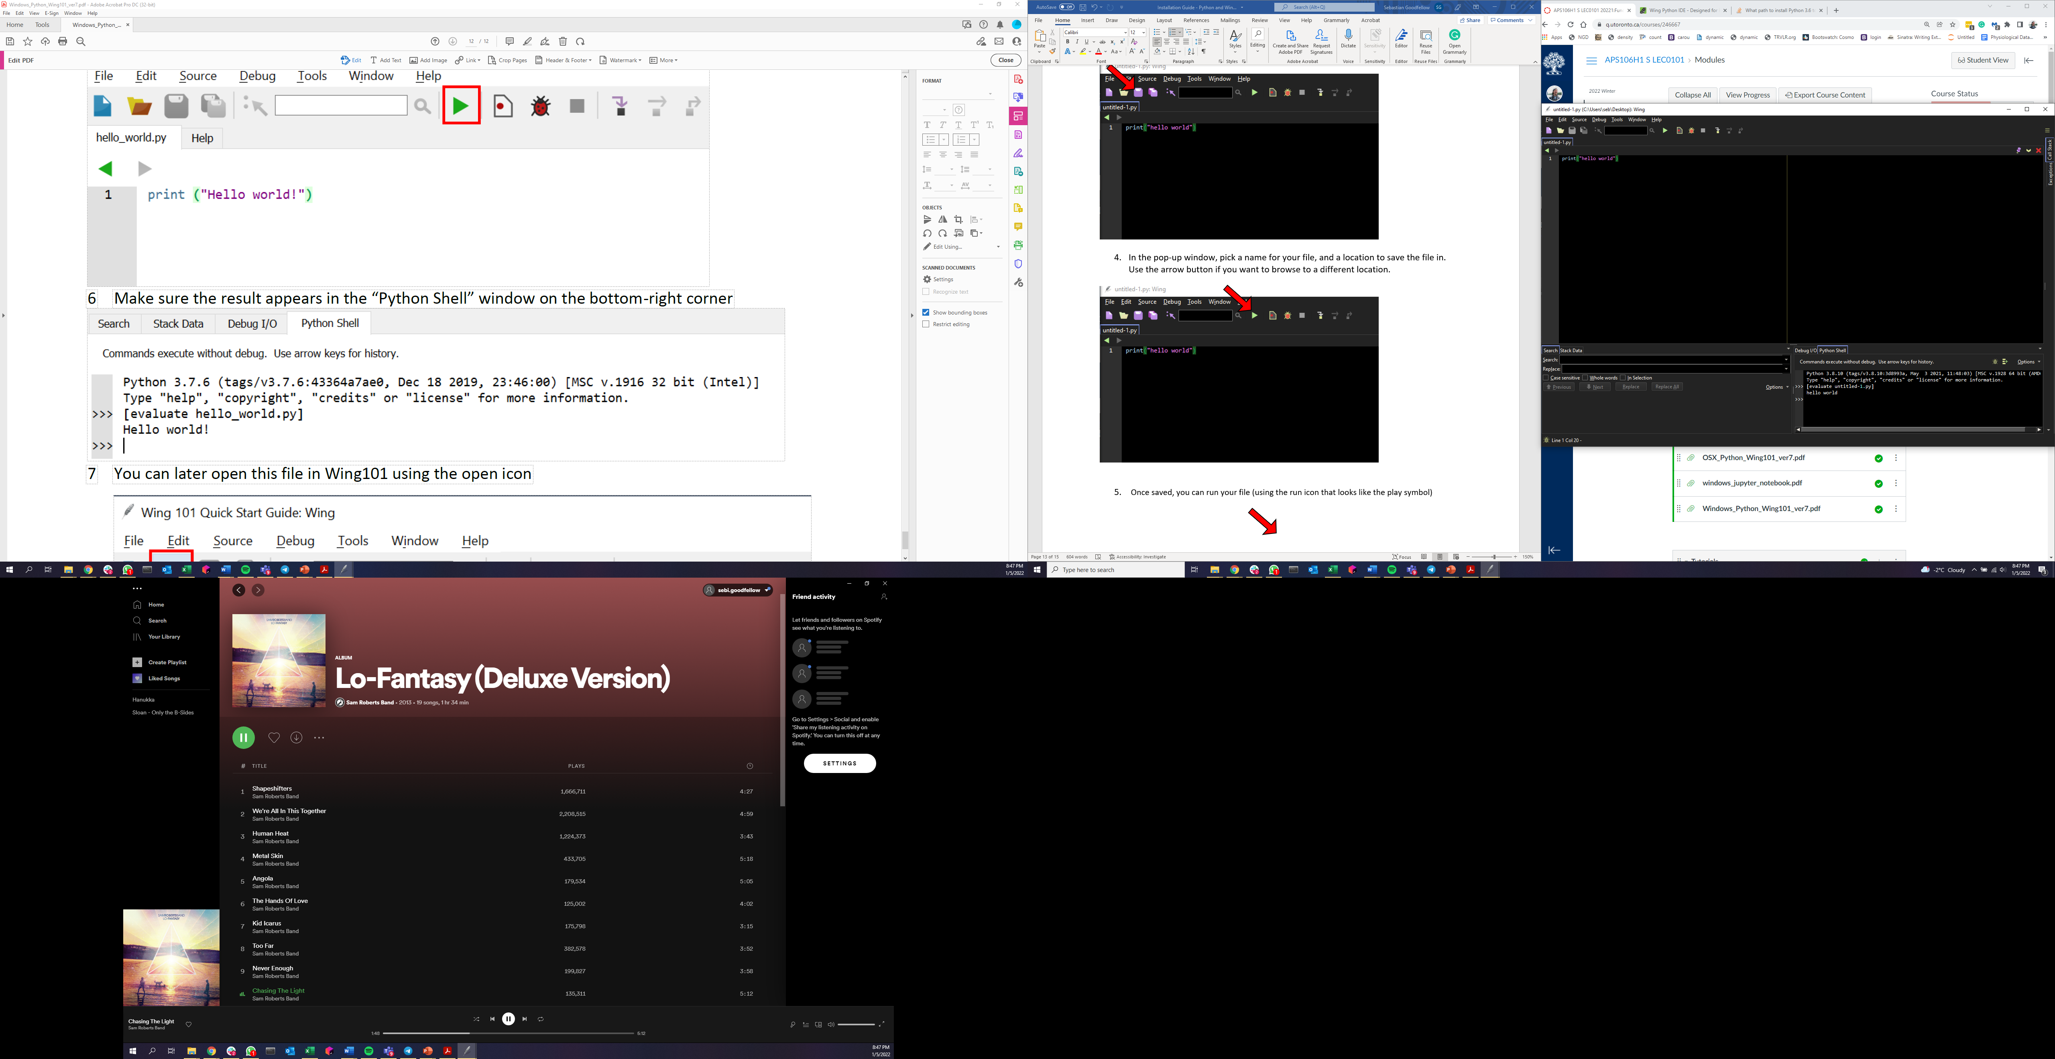

1. You can later open this file in Wing101 using the open icon
2. 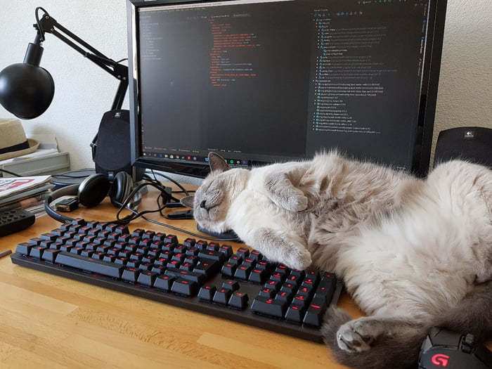Congratulations, you just wrote, saved, and ran you first Python program! You’ve earned a picture of a programming cat: